|  |  |  |  |
| --- | --- | --- | --- |
|  | **COLLEGE OF COMPUTING AND INFORMATION SCIENCES** | | |
| **Final-Term Assessment Spring 2021 Semester** | | |
| **Class Id** | 106325/106204/106205/106207/  106203/106206 | **Course Title** | OOP |
| **Program** | BSCS | **Campus / Shift** | Main Campus /Morning |
| **Date** | 4th – May 2021 | **Total Marks** | 40 |
| **Duration** | 2 hours and 15 minutes | **Faculty Name** | M.Zubair / Syed Umair Ali/ Umm e Kulsoom/ Arabi Tayyab |
| **Student Id** | 12113 | **Student Name** | Shahmeer khan (106204). |

**Instructions:**

* Fill out your Student ID and Student Name in above header.
* Do not remove or change any part of question paper.
* Write down your answers with title “Answer for Question# 00”.
* Handwritten text or image should be on A4 size page with clear visibility of contents.
* In case of CHEATING, COPIED material or any unfair means would result in negative marking or ZERO.
* Only PDF format will be accepted. Rename your files as **“YourName-YourRollNo.pdf”**.Other formats and named files will not be accepted.
* **Caution:**Duration to perform Final-Term Assessment is **02 hours and 15 minutes only**. Extra 45 minutes are given to cater all kinds of odds in submission of Answer-sheet. **Therefore, if you failed to upload answer sheet on LMS (in PDF format) within 3 hours limit, you would be considered as ABSENT/FAILED.**

Note : Only handwritten answer scripts will be accepted. You cannot attach screenshots of typed code.

Attempt any and only 4 questions

**QUESTION#1 -** **[10 points]**

Design a **Book** class that holds the title, author’s name, and price of the book. Books’s constructor

should initialize all of these data members except the price which is set to 500/-. Create a display

method that displays all fields.

All Books are priced at 500/- unless they are PopularBooks. The **PopularBooks** subclass replaces the

Bookprice and sets each Book’s price to 50,000/- through PopularBooks construcor. Override the

display method to display all fields.

Write a Main () method that declares an **array** of five **Book** objects. Ask the user to enter the title and

author for each of the 5 Books. Consider the Book to be a PopularBook if the author is one of the

following: Khaled Hosseini, Oscar Wilde, or Rembrandt. Display the five Books’ details.

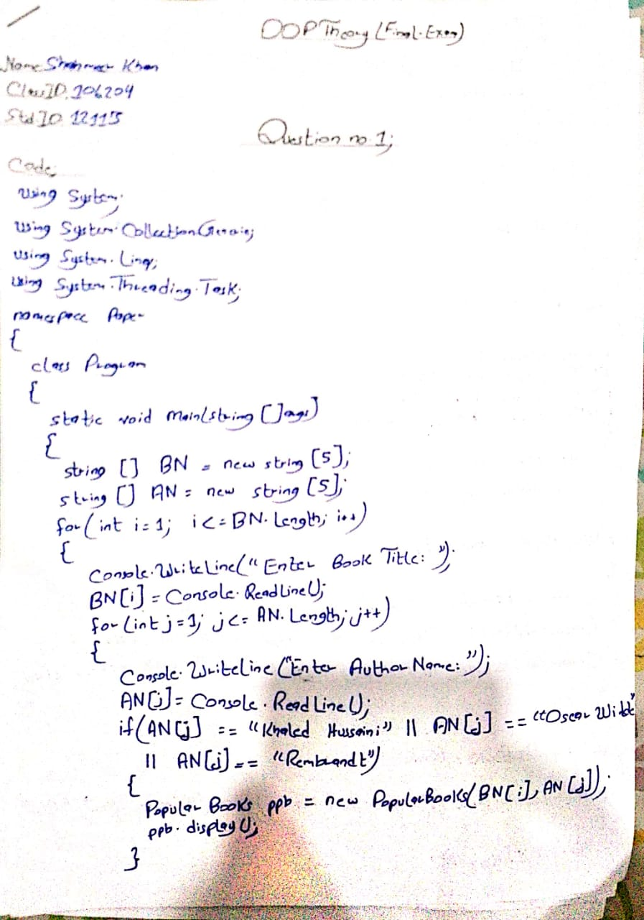

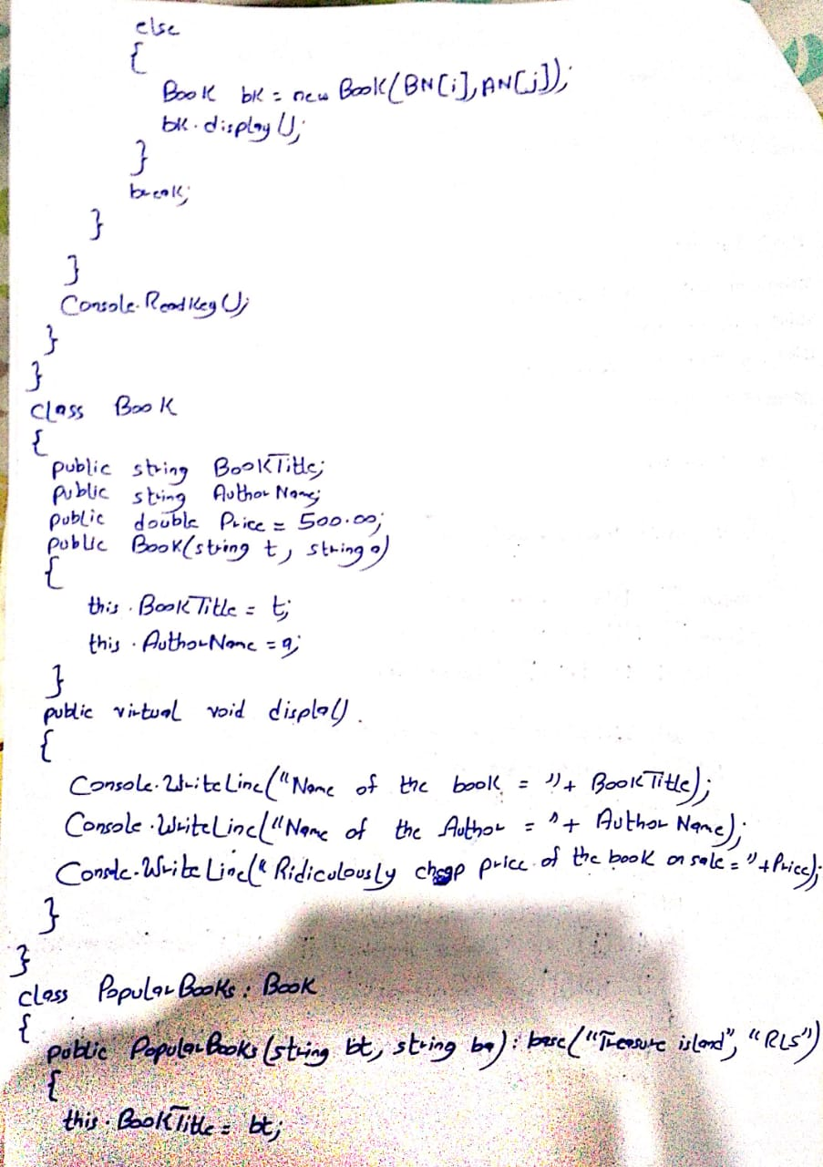

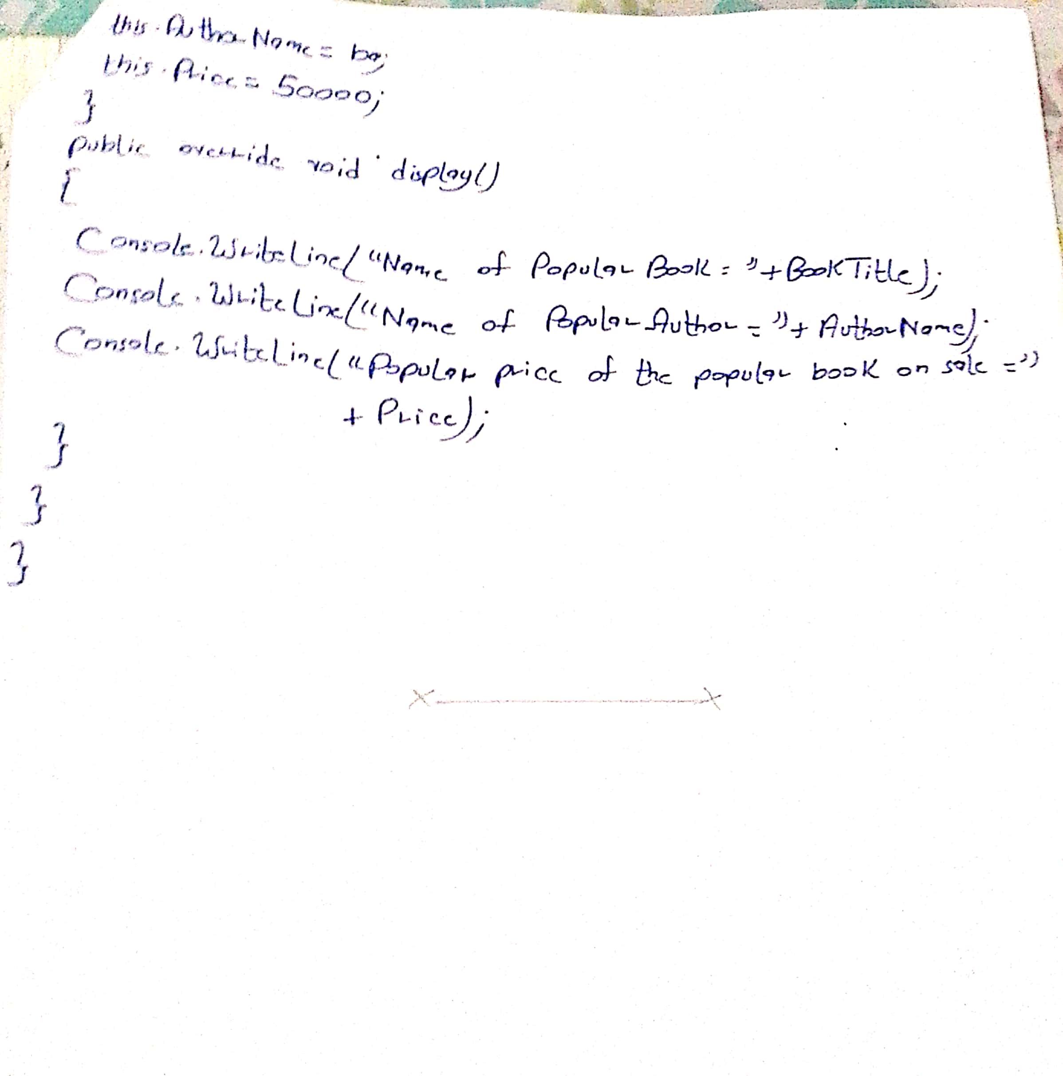

**QUESTION#2 -** **[10 points]**

Write the definition for the **Triangle** class that works for the following main() method.

public static void Main(string[] args)

{

Triangle tri1 = new Triangle(1.0,2.0);

Triangle tri2 = new Triangle(1.0,2.0);

Triangle tri3 = tri1 - tri2;

tri3.DisplayDetails();

if(tri1 == tri2)

{

Console.WriteLine(“The area is: “ +tri3.CalculateArea());

}

else

{

Console.WriteLine(“Area cannot be calculated.”);

}

}

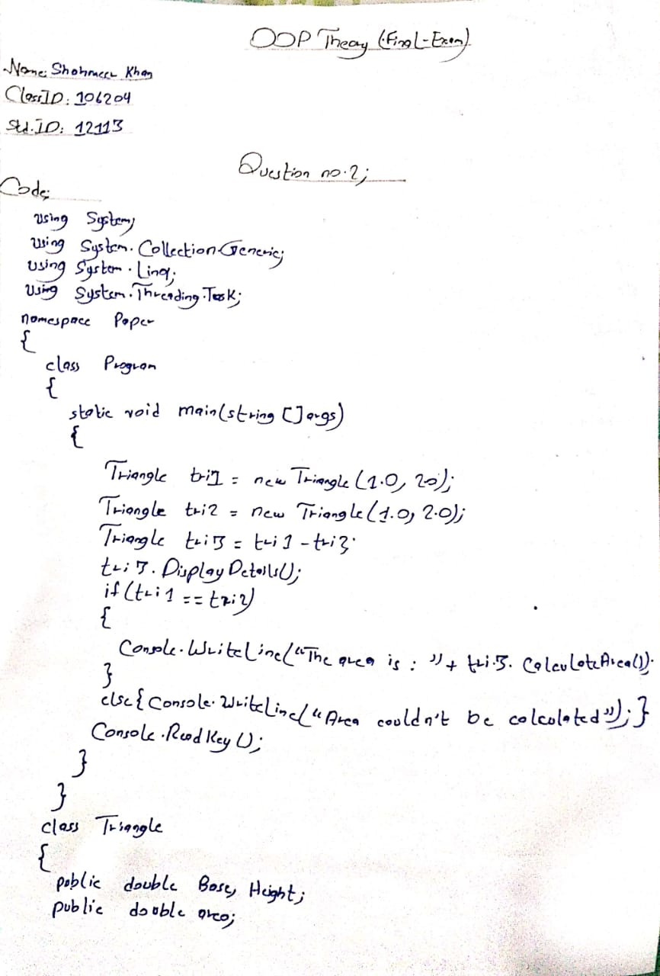

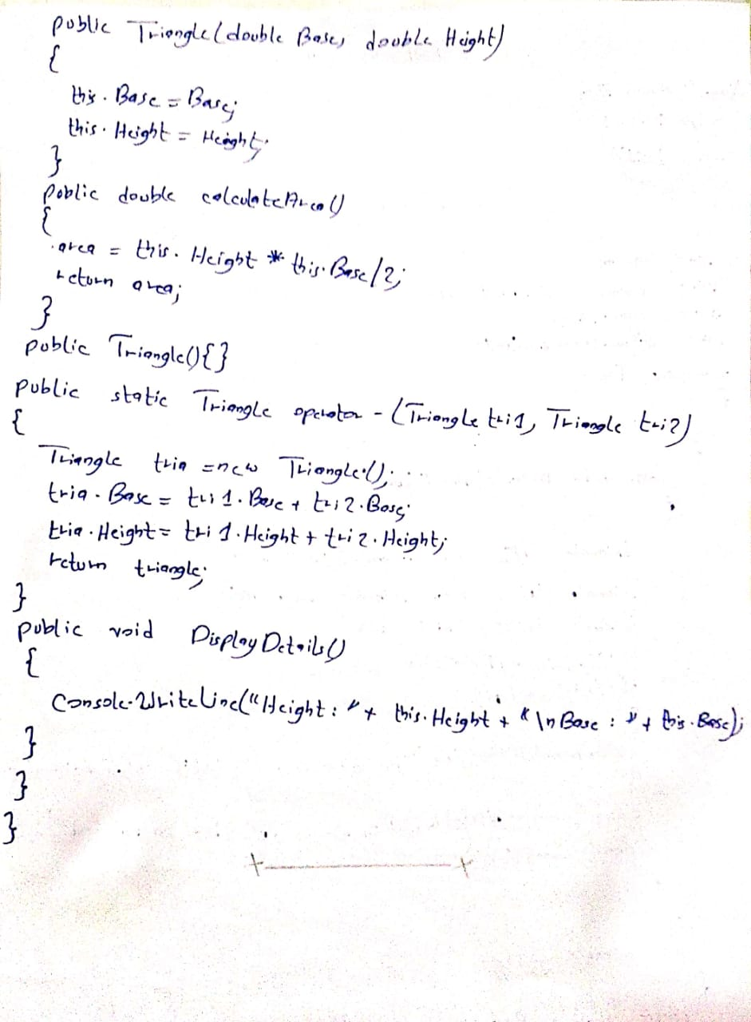

**QUESTION#3 -** **[10 points]**

A company plans to create a system for managing of a **movie** store. The movie store has a name,

address and phone number. **Movies** are described with title , genre, year of creation, number of sold

copies and list of songs. The **songs** are described with name and duration. Design a set of classes and

relationship between each other, which models the data of the record company. Implement a **test**

class, which demonstrates the work of rest of the classes.

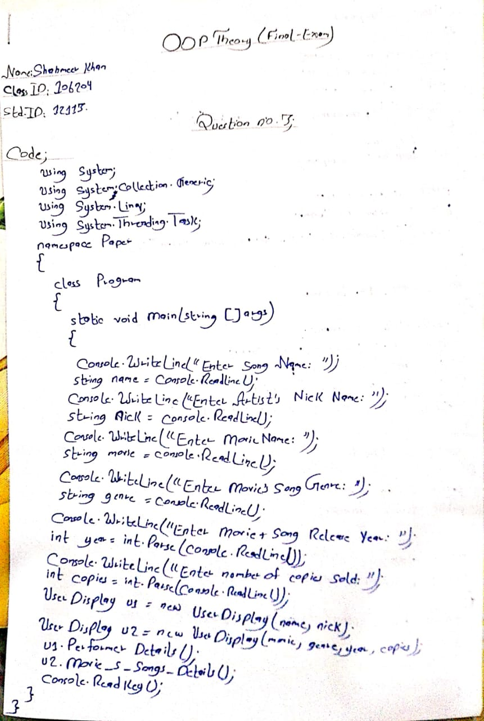

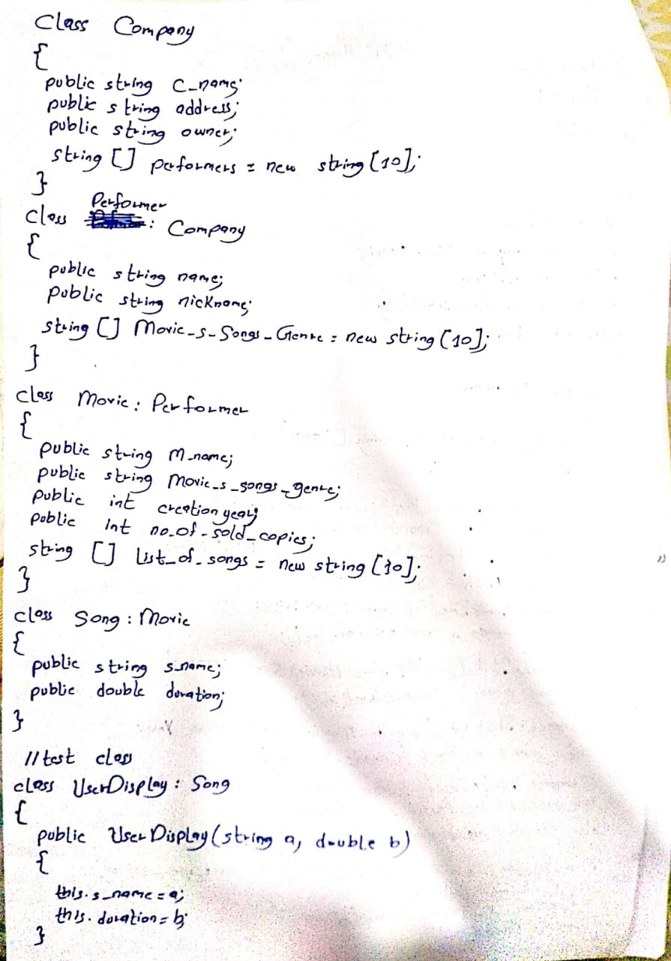

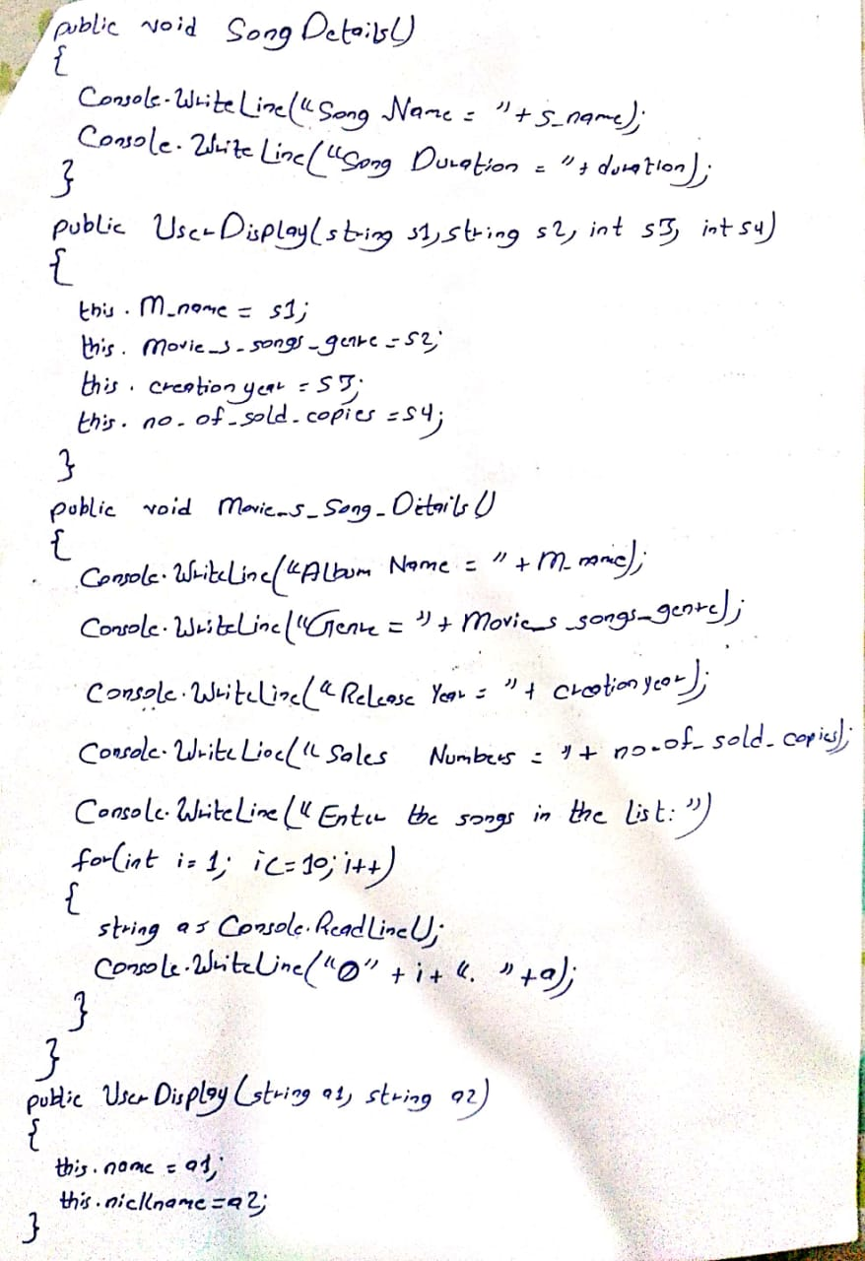

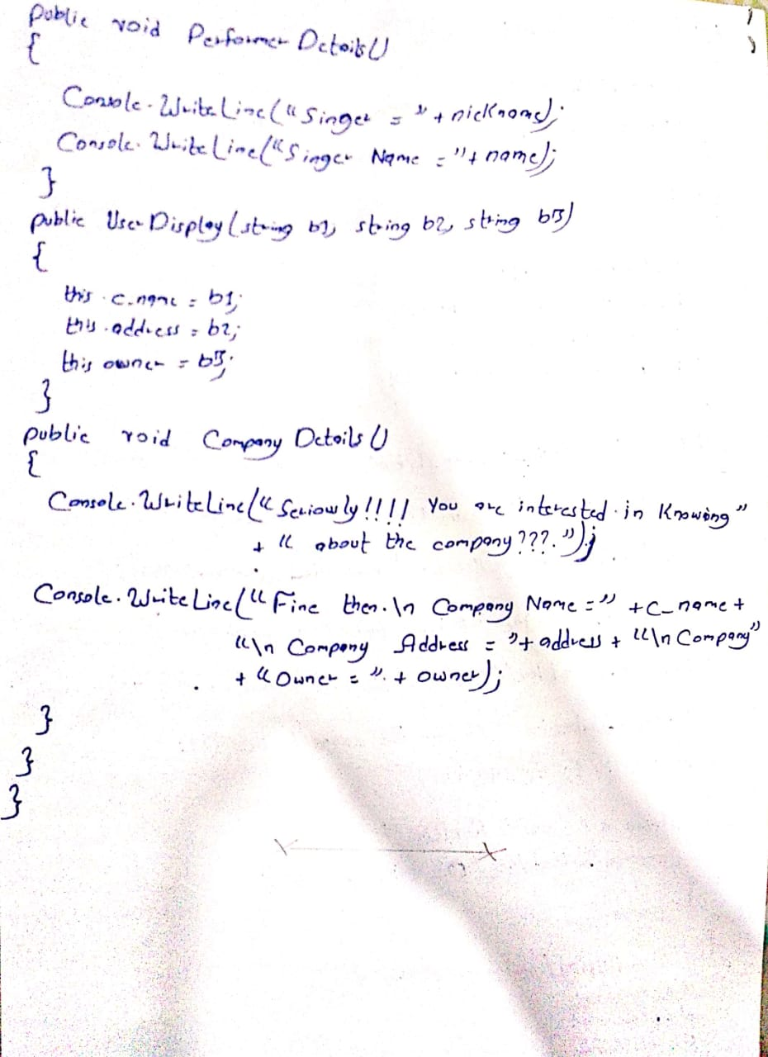

**QUESTION#4-** **[10 points]**

Provide **structural code**only for the following class diagram, implementing all the relationships.

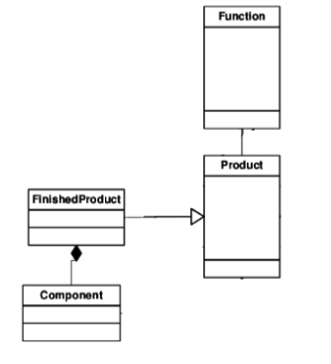

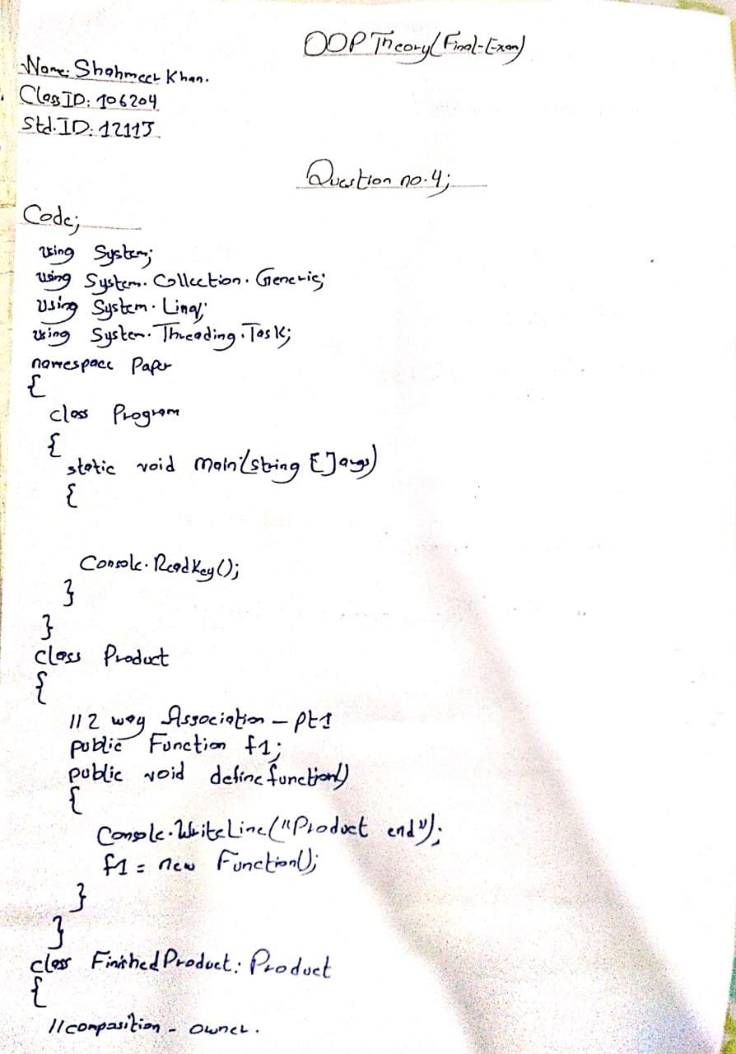

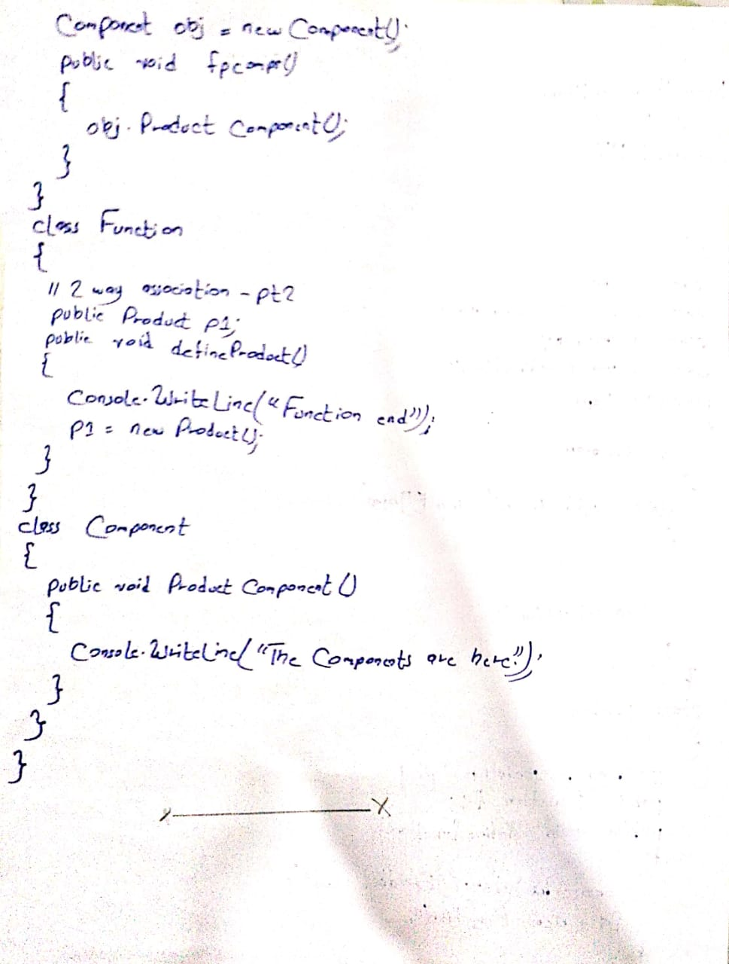

**QUESTION#5 -** **[10 points]**

Answer the following parts:

1. How an abstract class differs from an Interface?
2. Explain the concept of Composition and Association class relationships.
3. How Object-Oriented Programming differs from procedural programming?
4. Suppose a case scenario of an Animal with two of its type, Cat and Dog. Explainwhich one of these is the incorrect procedure to instantiate an object of typeanimal and why?

1. Animal c = new Cat();

2. Animal d = new Dog();

3. Cat c1 = new Dog();

4. Dog d1 = new Animal();

1. What are virtual functions?